***Hybrid FL + GAN + PCA + XAI (SHAP)***

***Tittle:*** *Privacy-Preserving Federated Learning with Conditional GAN Feature Augmentation for Explainable Medical Image Diagnosis*

***What is Federated Learning (FL)***

***--------------------------------------------------***

* Federated Learning (FL) is a machine learning technique that allows multiple clients (like hospitals, mobile devices, or organizations) to train a shared model collaboratively without sharing **their raw data with anyone**.
* So instead of sending **data to a central server, each client trains the model locally on its own dataset and sends** only the model updates (weights or gradients) back to the server.

|  |
| --- |
|  |

***How It Works (Simple Overview)***

=> **Server** initializes a global model.

=> Server sends the global model to **each client**.

=> Each client **trains the model locally using its private data**.

=> Each client sends back **only model updates (no data).**

=> The server aggregates all updates (usually via averaging).

=> The global model is updated and the **process repeats**.

We working on a Hybrid FL + GAN + PCA + XAI system , so here’s how FL fits in:

* FL → Enables collaboration among **distributed clients (like hospitals or labs)** securely.
* GAN → Generates **synthetic brain MRI data to augment limited local data.**
* PCA → Reduces dimensionality to simplify communication and reduce computation between clients and the central server.
* XAI (e.g., SHAP, Grad-CAM) → Explains how the federated global model makes its predictions (for trust and interpretability).

***GAN: Generative Adversarial Network***

***---------------------------------------------------***

* GAN is a two-player game between **Generator** and **Discriminator** 
  + - Generator → makes fake but realistic MRI images.
    - Discriminator → judges if images are real or fake.
    - Together → they create high-quality synthetic data that can improve your research.
* Generator (G)
  + - Input: random noise (like Gaussian noise or latent vector).
    - Output: fake data (e.g., fake MRI images).
    - Goal: generate realistic images that look like real MRIs.
* Discriminator (D)
  + - Input: real MRI images + generated (fake) images.
    - Output: probability (real or fake).
    - Goal: distinguish between real and fake images.
* Short Note:
  + - Generator improves at making images more realistic.
    - Discriminator improves at detecting fakes.
* Type of GAN
* Vanilla GAN (Basic GAN)
  + - * The original GAN by Ian Goodfellow.
      * Generator + Discriminator trained simultaneously.
      * Works fine on simple datasets, but unstable on complex images (like MRIs).
* DCGAN (Deep Convolutional GAN)
* Uses **CNNs** (Convolutional Neural Networks) in Generator & Discriminator.
* Much better at generating high-quality images (faces, medical images).
* Commonly used for **MRI, X-ray, CT image synthesis**.
* **Conditional GAN (cGAN)** 
  + - * Adds **labels** as input (e.g., tumor type: Meningioma, Pituitary, etc.).
      * Generator learns to create images **conditioned on the class label**.
      * Very useful for **class-specific MRI generation**.

***How GAN works:***

***Step 1: Import Libraries***

* You’d use PyTorch or TensorFlow/Keras.

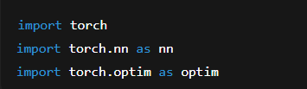

***Step 2: Define Generator***

* Input: random noise vector (e.g., 100 numbers).
* Output: fake MRI image.

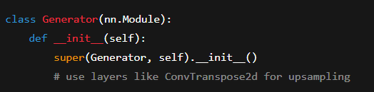

***Step 3: Define Discriminator***

* Input: real MRI or fake MRI.
* Output: probability (real = 1, fake = 0).

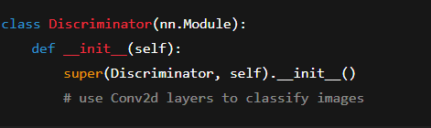

***Step 4: Loss Function***

* GANs usually use Binary Cross Entropy (BCE) Loss.
* Discriminator tries to maximize: log(D(x)) + log(1 - D(G(z))).
* Generator tries to minimize: log(1 - D(G(z))).

***Step 5: Training Loop***

1=> Sample real MRI images.

2=> Sample noise → generate fake images.

3=> Train Discriminator:

* Show real → label = 1.
* Show fake → label = 0.

4=> Train Generator:

* Generate fake images.
* Trick the Discriminator into labeling them as real (label = 1).

This repeats for many epochs until Generator produces realistic MRIs.

**What we will do is 🡺**

|  |
| --- |
|  |

***MRI Images***

***↓***

***ResNet18 (Feature Extractor)***

***↓***

***512-D Features (per image)***

***↓***

***[Conditional GAN]***

***→ Generator creates synthetic 512-D feature per class***

***→ Discriminator ensures realism***

***↓***

***(Real + Synthetic features)***

***↓***

***Client-wise Merge → Aggregation***

***↓***

***Scaling + PCA (→100-D)***

***↓***

***MLP Classifier (Final Training)***

*Our cGAN* ***(Conditional Generative Adversarial Network)*** *is designed to generate* ***synthetic ResNet18*** *feature vectors (512-D) for each tumor class (glioma, meningioma, pituitary, no-tumor).*

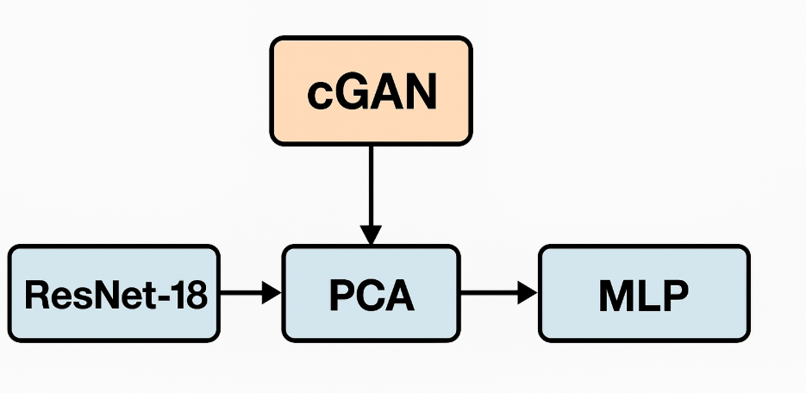

***Step 5 → Step 8****. In Coding portion*

***Step 1: ResNet18 → Feature Extraction***

* Purpose: Convert **high-dimensional image** pixels into **compact, meaningful feature embeddings**.
* ResNet18 is a **pretrained convolutional neural network** (CNN) on ImageNet.
* It extracts hierarchical visual features such as edges, shapes, and textures.
* The output from ResNet18’s penultimate layer (before classification head) is typically a **512-dimensional vector per image.**

***Why CNN???***

* A **CNN (e.g., ResNet18, DenSNet-18 or ResNet-50 etc)** acts as a **feature encoder** (edges → textures → shapes → organs → tumors, etc.).
* In medical imaging or any visual domain, you **don’t want the GAN to learn from raw pixels alone** — that’s unstable and data-hungry.

So you use a pretrained CNN first to:

* Extract meaningful features from images.
* Provide **structured, lower-dimensional** inputs for the GAN.
* Help the GAN learn faster and more stably because it works on latent features, not **raw pixel grids**.

***Why not feed raw images directly to PCA/MLP?***

* Because PCA and MLP expect structured numerical features, not raw pixel grids.
* ResNet18 converts those complex pixel patterns into semantic representations.

***Step 2: PCA → Dimensionality Reduction***

***What is PCA?***

* Principal Component Analysis (PCA) is a dimensionality reduction technique
* PCA converts your **large number of features into a smaller number of principal** components that still capture most of the data’s meaning.

***Why Do We Use PCA?***

* Reduce complexity —> fewer features → faster model training.
* Remove noise and redundancy — >correlated or less-informative features are merged.
* Improve visualization —> high-dimensional data can be projected into 2D or 3D for easy plotting.
* The 512 features from ResNet18 may contain redundant information.
* PCA reduces them to fewer principal components (say, 128 or 256) while retaining most of the variance.

This step:

* + Removes noise and correlation between features.
  + Speeds up training.
  + Prevents overfitting when you have limited data.

➡️ PCA acts as a **feature compressor before feeding** into your next stage.

***Step 3: MLP → Classification or Integration***

An MLP is one of the most fundamental architectures in deep learning 🡪A fully connected neural network that learns to map **inputs to outputs** through layers of neurons.

🡺A system that learns patterns or relationships between input features and their correct outputs.🡸

General Structure of MLP is

**Input** → Hidden Layer(s) → **Output**

Each layer has **neurons that are connected to every neuron in the next layer** (hence “fully connected”).

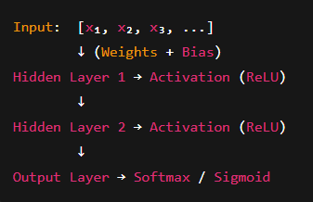

* The reduced PCA features are then passed into an MLP (Multi-Layer Perceptron) for **final classification** (or regression).
* The MLP learns the mapping between these compressed features and the output labels.
* It’s a lightweight, flexible classifier that can fine-tune decision boundaries.

***Step 4: Where cGAN Fits In***

* The cGAN (Conditional GAN) generates synthetic feature vectors or images conditioned on class labels.
* It can be inserted before PCA (if generating new features) or after PCA (if generating latent features in compressed form).

Purpose:

* To augment data.
* To balance classes (especially for medical datasets).
* To improve the downstream MLP’s robustness.

**🧬 Example Hybrid Architecture**

Image ─▶ CNN (e.g., ResNet18/DenseNet121)

└─▶ Real Features ─┬─▶ PCA ─▶ MLP ─▶ Output

│

└─▶ cGAN (Generator + Discriminator)

└─▶ Synthetic Features (augment dataset)

***Final Diagram:***

**pipeline diagram** showing **FL + cGAN + ResNet18 + PCA + MLP**

